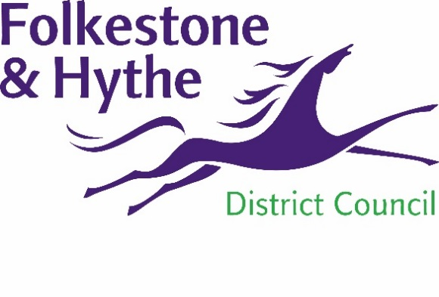
NEWS RELEASE

25 October 2021

CLEARANCE WORK STARTS AT PRINCES PARADE SITE

Vegetation is to be cleared from areas of the Princes Parade development site from this week following a successful phase of reptile capturing.
Work to safely and sensitively relocate slow worms, common lizards and grass snakes from the former municipal waste tip to suitable habitat within the Royal Military Canal corridor began in August 2021.
This has now been completed in line with the appropriate guidelines and planning conditions by suitably qualified ecologists.
Some vegetation now needs to be cleared to ensure all reptiles have been found and that those already relocated do not return to what is now a site becoming ready for construction.
A Folkestone & Hythe District Council spokesperson said: “While we are confident the vast majority of reptiles have been found, it is common for clearance work of this nature to take place to ensure that is the case.
“It will, once again, be overseen by experienced ecologists. The cutting back – depending on the weather conditions – could generate some noise and dust in the local area but we will minimise any impact wherever possible.
“Our timetable was specifically designed with the aim of ensuring any visual impact was delayed until after the summer months.”
With the scheme progressing at a good pace, Heras fencing now needs to be placed on the site’s boundaries to ensure the area is secure and keeps the public safe and away from what will soon be a construction site.
Access will remain through the site via the central path bisecting the site and along the path to the western edge of the boundary with the golf course.
The fencing will have no impact on the ongoing badger relocation work as access will remain and they can continue to move freely on the site.
These works are essential to ensure we deliver the council’s long-held ambitions to replace our popular – but costly and rapidly deteriorating – swimming pool in Hythe with facilities with new accessible open spaces fit for the 21st century. You can find out more about the project by clicking here.

ENDS
Notes to Editors
For more information, please email communications@folkestone-hythe.gov.uk

Follow us on Facebook: @FolkestoneandHytheDC
Follow us on Twitter: @fstonehythedc
Follow us on Instagram: @folkestonehythedc
Follow us on LinkedIn: Folkestone & Hythe District Council

